Lab#15
OPEN ENDED
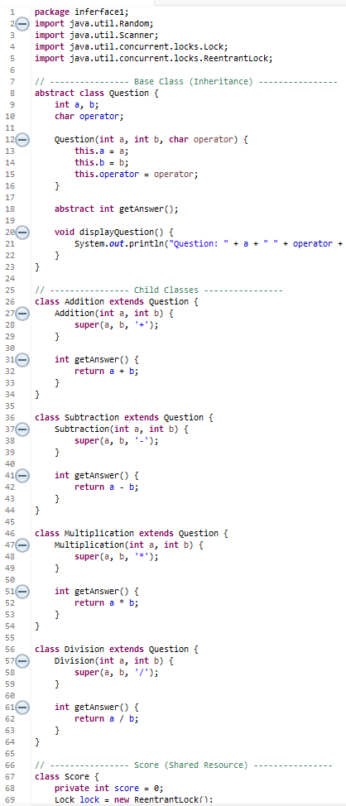
The objective of this program is to create a Math Quiz Game for Kids that helps children practice basic math operations in a fun way. It also demonstrates the use of multithreading, synchronization, and exception handling in Java.
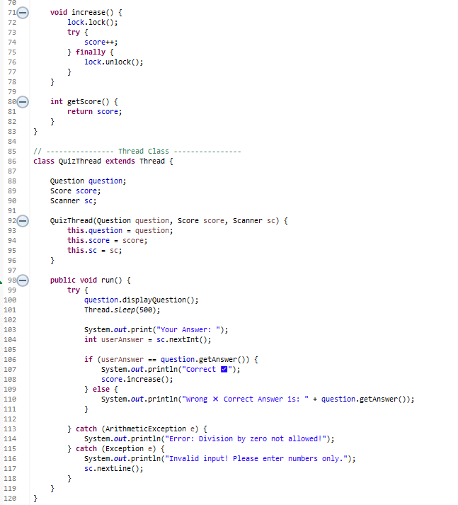
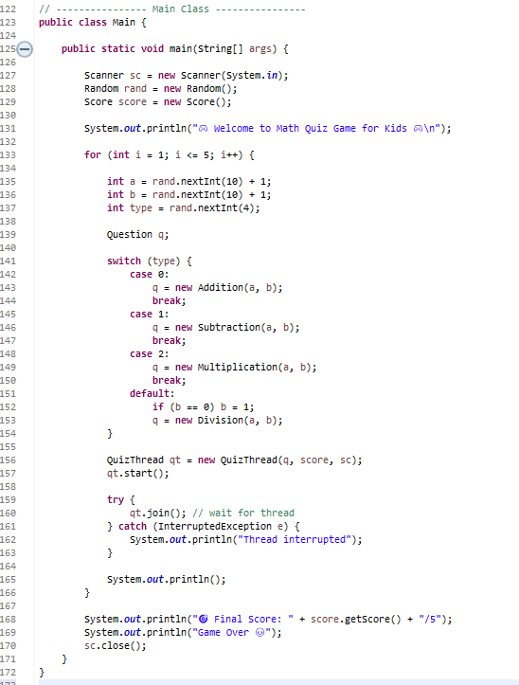
Output:
